**NETWORKING & SYSTEM ADMINISTRATION LAB**

**Name: DELNA ANNA JOY**

**Roll No: 45**

**Batch: A**

**Date: 19-03-2022**

**Experiment No.: 1**

**Aim**

Require a comparative study of specifications of Desktops and Server class computers.

**Procedure**

**Desktops**

A desktop computer is a personal computer designed for regular use at a single region or near a desk due to its size and power requirements. The most common configuration has a case that houses the power supply, motherboard (a printed circuit board with a microprocessor as the central processing unit, memory, bus, certain peripherals and other electronic components), disk storage (usually one or more hard disk drives, solid state drives, optical disc drives, and in early models a floppy disk drive); a keyboard and mouse for input; and a computer monitor, speakers, and, often, a printer for output. The case may be oriented horizontally or vertically and placed either underneath, beside, or on top of a desk.

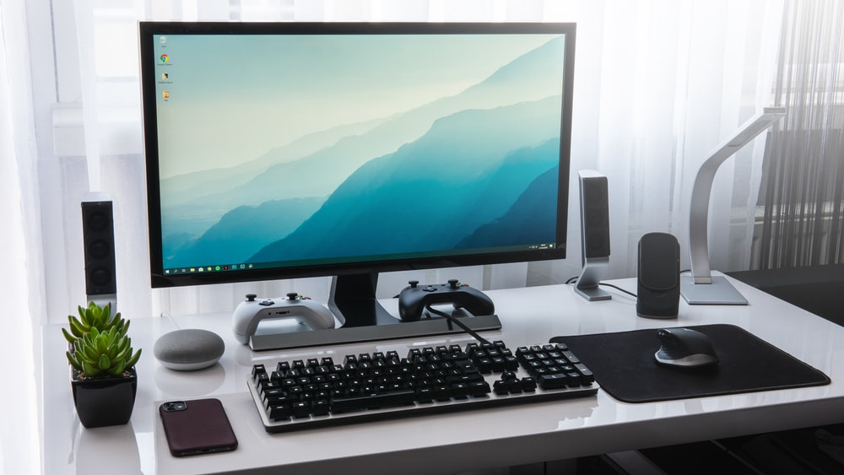

Server class

Designating a computer as "server-class hardware" implies that it is specialized for running servers on it. This often implies that it is more powerful and reliable than standard personalcomputers, but alternatively, large computing cluster may be composed of many relatively simple, replaceable server components.

Servers are database servers, file servers, mail servers, print servers, web servers, game servers, and application servers. Client–server systems are usually most frequently implemented by the request–response model: a client sends a request to the server, which performs some action and sends a response back to the client, typically with a result or acknowledgment. Designating a computer as "server-class hardware" implies that it is specialized for running servers on it. This often implies that it is more powerful and reliable than standard personal computers, but alternatively, large computing clusters may be composed of many relatively simple, replaceable server components.

